Design brief (Dylan)

Colour Scheme: Triadic colour scheme

Colour Palette: yellow-orange, blue-green, red-violet

|  |  |
| --- | --- |
| **Color Name:** | Red Violet |
| **Hex Color Code:** | #C71585 |
| **RGB Color Code:** | RGB(199, 21, 133) |
| **CMYK Values*:** | 0.0%, 89.4%, 33.2%, 22.0% |
| **Color Name:** | Yellow Orange |
| **Hex Color Code:** | #FFAE42 |
| **RGB Color Code:** | RGB(255, 174, 66) |
| **CMYK Values*:** | 0.0%, 31.8%, 74.1%, 0.0% |
| **Color Name:** | Blue Green |
| **Hex Color Code:** | #008080 |
| **RGB Color Code:** | RGB(0, 128, 128) |
| **CMYK Values*:** | 100.0%, 0.0%, 0.0%, 49.8% |

Font used: Roboto and Segoe UI Variable

Design rationale:

The goal is to design something vibrant and energetic that stands out when user looks at them, it aims to attract people who are at vibrant at heart. I want to create a fashion brand selling shirts, pants, shoes and other fashion accessories as I enjoy apparel. Overall, the design is kept as efficient as possible, removing any fine details while showing the idea of an original design.

The design principles applied are balance as the design has a rationale of using the three colours equally/proportionally and there is symmetrical balance used in the brand logo. Spreading out colours allow the designs to be more lively and interesting, allowing viewers to feel stimulated when looking at it. Even almost every outline in each design utilise the colour schemes for more consistency. Principle of unity is shown by using geometric shapes such as squares, rectangles appearing consistently in each design and the logo brand.

I chose a triadic colour scheme as it is vibrant and lively feeling to show the brand is upbeat thus I chose red- violet as part of my colour scheme to represent royalty and passionate ambitions which takes reference from my slogan “Wear your wishes” to tell people that meh-lan is a fashion brand where consumers will be able to wear something they wish for, yellow-orange helps to convey optimism, excitement and enthusiasm which associate with positive energy, it does also attract users attention easily. Blue-green represent morality which shows the brand conforms to high standard of doing good and create a balance in this triadic colour scheme.

Design process(Back of business card):

This is an example of a poor layout use without emphasis on necessary important things that need the user attention. I initally planned written this, worrying that users will not understand the written text thus I decided to label with a name etc…

It is also too cramped and it will not captivate users attention well despite using bolder style. Contact number can be spaced out and include a calling code to show that is a phone number rather than just a string of numbers.

Updated design(1):

There is more whitespace around the text. The text feels much more breathable allowing which help prevents the design from feeling cluttered. More emphasis has been given to the visual details that need more attention such as emphasising the name by increasing the font size. Phone number and address have been changed to make it more realistic.

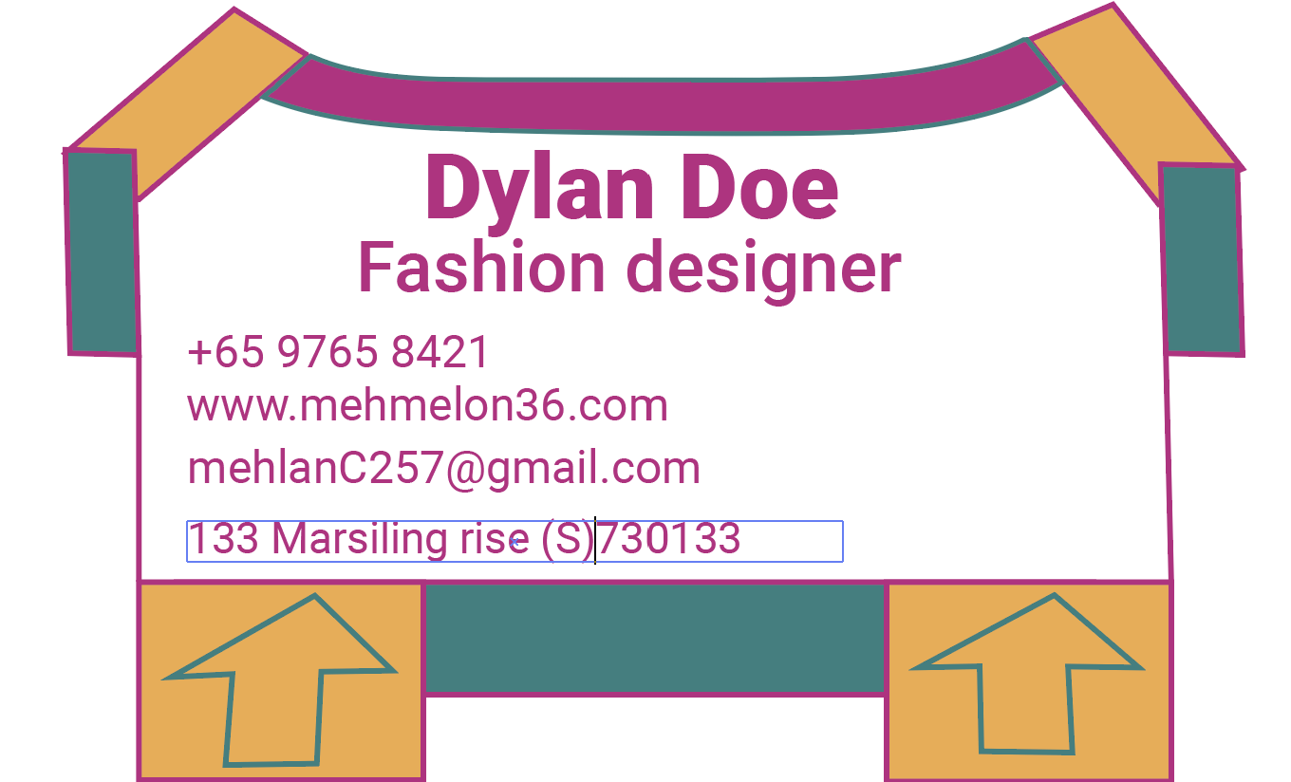

Final design:

I shifted elements which improve the visual of the business card. The arrows has been shifted which help makes it less distracting for readers. Further emphasis has been placed on the name by bolding and increasing the font even more. Entrepreneur has been changed into designer, giving the name card greater whitespace. I rearranged the information to make it neater and add in the postal code for clarity. It has a more distinguished visual hierarchy and visual flow.

Design process(front of business card):

Colours were not used efficiently as colour proportion is not balanced and there is too much green at the bottom and too much yellow at the top. and the emphasis was not strong enough and there were many visual elements that distract the reader.

Final design:

I shifted visual element (hook) and remove certain visual elements(triangles and semicircles) and replace them with other visual element(the long rectangle at the top) and make the logo bigger, brand name bolder and the logo outline thicker, fonts of the brand name and slogan has been increased to show emphasis. Visual hierarchy has been applied to the brand name and slogan. I improved the colour proportion to make the design more balanced in terms of colours.

I feel that shifitng the hook to the left makes the business card more unique and original as a physical hanger will always have their hook in the middle. The removal of certain elements help with keeping the business card more simpler and less distracting. The logo does have symmetrical balance applied.

(more details can be found in design rationale of business card template)

Stickers:

Stickers design concept and design principles applied is similar to business card concept except different geometric shapes such as oval and circle appear more often. Typography has been used to help words stand out appropriately such as uppercase the word BUY !!! found in one of the stickers

(more details can be found in design rationale of sticker template)

Webpage:

Similar to both sticker and business card concept except design concept has been simplified further and design principles applied is similar to both sticker and business card. Visual hierarchy has been applied consistently in all four webpages and emphasis of typography has been applied.

(more details can be found in design rationale of webpage template)